# History of Chandana:

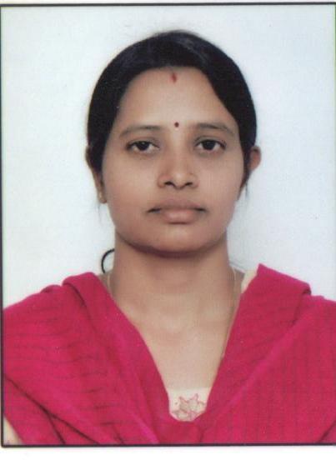Name: Chandana D/o Sunitha

Date of Birth/Age: years.

Class: thStd (English medium state syllabus).

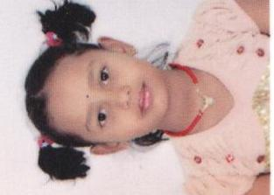Address: # 71, subbamma Circle

Sarakki,

Bangalore -78

Chandana is a bright quite girl who wants to aspire great in her life. Chandana is the second daughter of Mrs. Sunitha. She has lost her first daughter due to heart dieses. The same problem has been found with Chandana too, but she has been under regular checkups and control. Because of this Sunitha’s husband divorced since six years.

Suntiha being SSLC failed and got early married still she is trying to bring up her daughter with good education. Suntiha is on the breadline, no support from any of her relatives. Therefore she has been doing domestic work and earning Rs. 4000/- a month. Since Chadana is doing well in studies, her mother trying all her effort to continue in her studies.

Sunitha has found a good institute with the help of a social worker, where they have given admission for school with boarding. By seeing her intelligence and genuineness the Institute has given free hostel but for school they are looking for sponsorship of rupees fifteen thousand for annam. Therefore chandana is desperately looking for educational sponsorship.

The name of the institute is **Sahasra Deepika International for Education is** a registered organization providing good education and boarding for more than 50 children every year. They are eligible to receive support from local as well as from international.

Thank you

With regards.

Mr. Jayapaul. 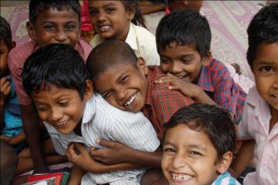

Social worker